[ Insert official UPAEP logo ]
UPAEP · Decanato de Ingenierías
EVIDENCE — US25-T5
Test the registration flow
SmartGreenAI: Cilantro Crop

1. Task information
Task ID | US25-T5
User Story | US-25 — Register IoT devices, sensors and actuators
Sprint | Sprint 2 (2026-09-21 – 2026-10-09)
Week | Week 3
Responsible | Alexis Enrique Valle Parra
Peer reviewer | Jorge Velez Delgado
Planned / actual hours | 2 h / 2 h
Completed on | October 8, 2026
Status | Done

2. Task description
Register a device with its sensors and actuators, send data with its token, then deactivate it and verify that its data is rejected.

3. Completion conditions
✓ Condition 1: Full flow executed: register, send data with token, deactivate, data rejected.
How it was verified: The full flow was executed: register the device with its sensor and actuator, send data with its token, deactivate it and try again.
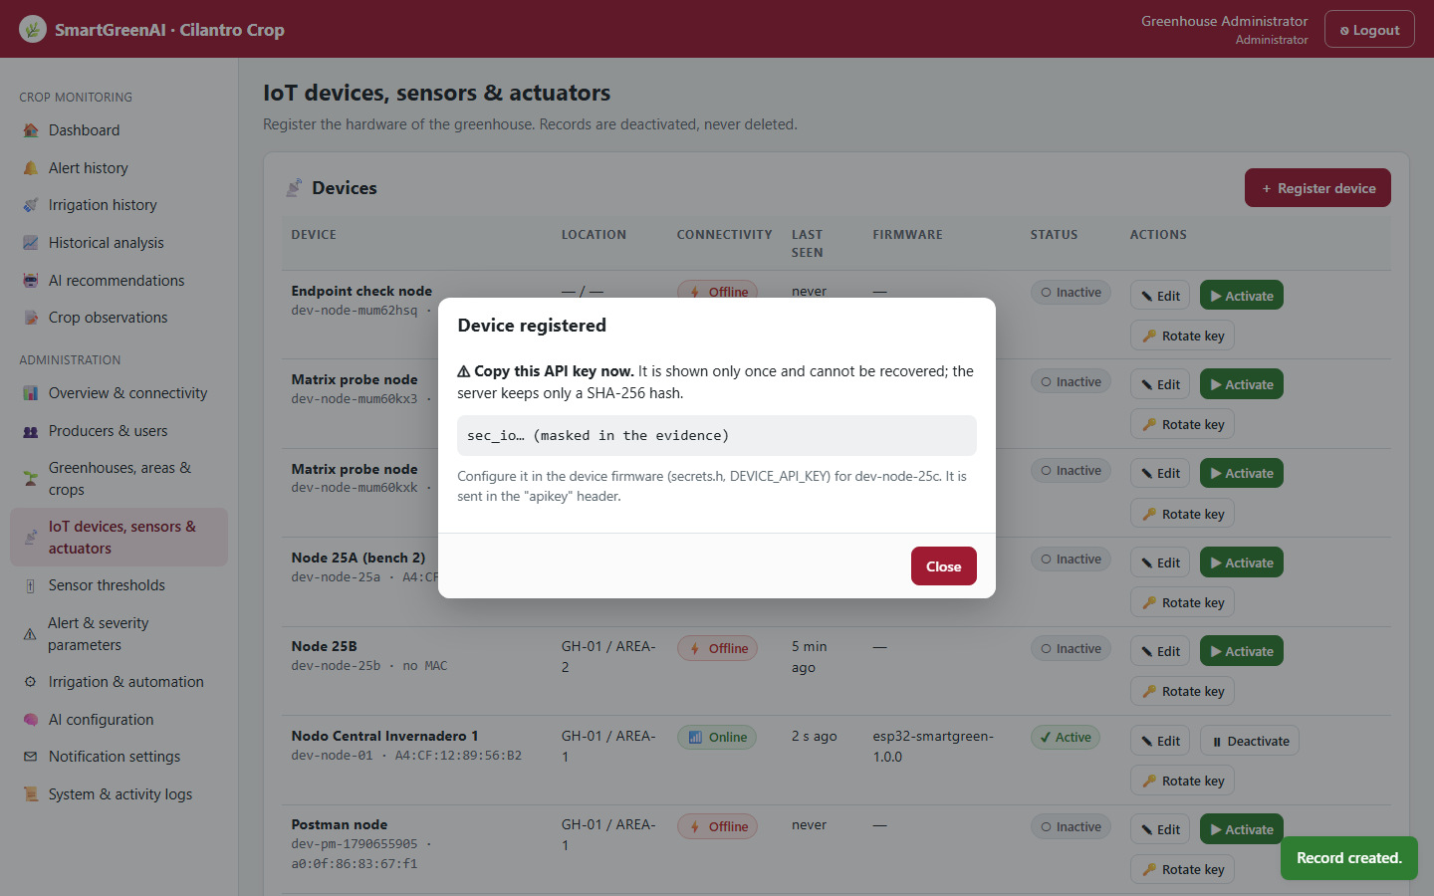
Figure US25-T5-1. Step 1 — device registered from the screen; its API key is shown once (masked here). (US25-T5_Test_Registration_Flow_1.png)
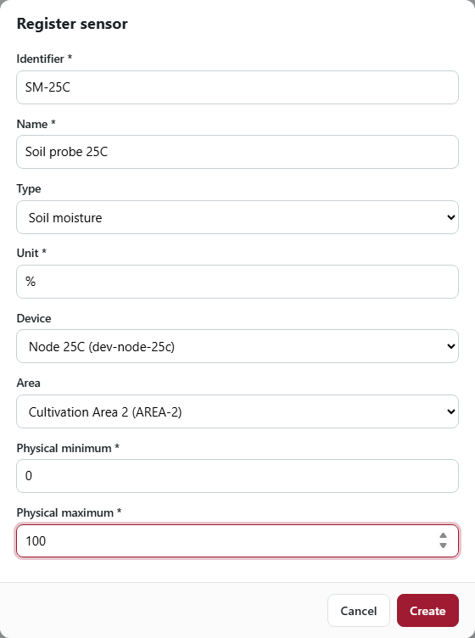
Figure US25-T5-2. Step 2 — adding the sensor SM-25C to the new device. (US25-T5_Test_Registration_Flow_2.png)
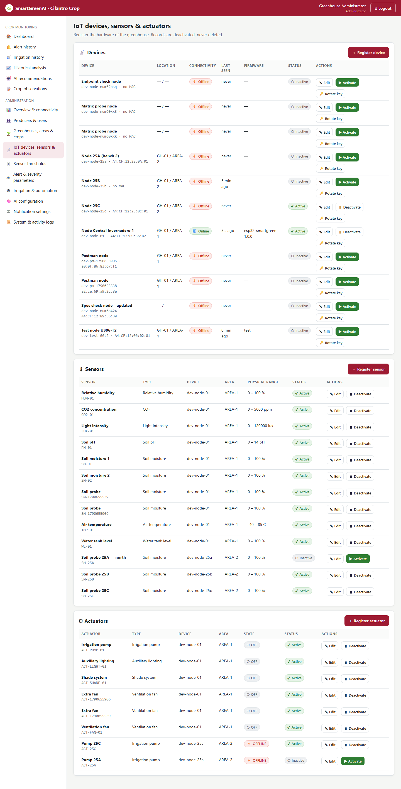
Figure US25-T5-3. Step 3 — the device, its sensor and its actuator appear in the registry. (US25-T5_Test_Registration_Flow_3.png)
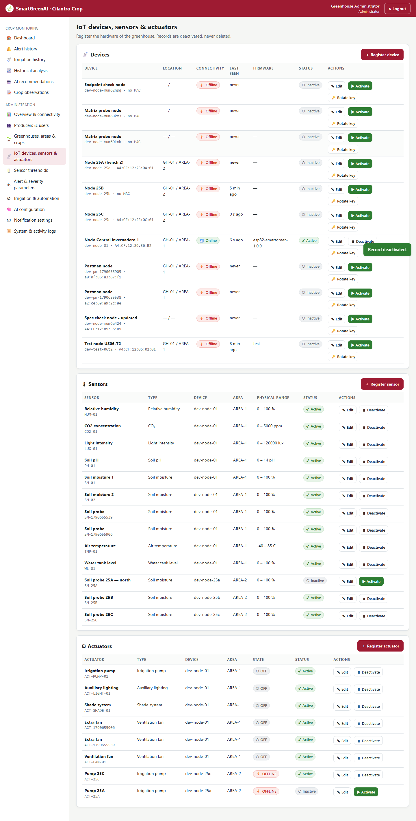
Figure US25-T5-4. Step 4 — the device was deactivated from the screen (status Inactive). (US25-T5_Test_Registration_Flow_4.png)
✓ Condition 2: All steps passed.
How it was verified: All 6 steps passed: the data sent while active was stored and the data sent after deactivation was rejected.
Transmission before and after deactivation (attached: US25-T5_Test_Registration_Flow_7.txt)
POST /api/measurements
apikey: sec_io…
{
"device_id": "dev-node-25c",
"sensor_id": "SM-25C",
"value": 64.2,
"unit": "%",
"recorded_at": "2026-09-29T04:25:23.154Z"
}
→ HTTP 201 Created (40 ms)
{
"id": "msr-aaf0c49533cd",
"sensor_id": "SM-25C",
"status": "processed",
"inserted_at": "2026-09-29T04:25:23.176Z",
"alert": null,
"anomalies": []
}
POST /api/measurements
apikey: sec_io…
{
"device_id": "dev-node-25c",
"sensor_id": "SM-25C",
"value": 64.3,
"unit": "%",
"recorded_at": "2026-09-29T04:25:24.284Z"
}
→ HTTP 401 Unauthorized (12 ms)
{
"status": 401,
"code": "ERR_AUTH_REQUIRED",
"message": "The device API key is invalid or the device is deactivated.",
"details": []
}

Readings of SM-25C in the database (only the one sent while active) (1 rows; US25-T5_Test_Registration_Flow_5.csv)
sensor_id | value | recorded_at | received_at
SM-25C | 64.200 | 2026-09-29T04:25:23.154Z | 2026-09-29T04:25:23.176Z
SQL: SELECT sensor_id, value, recorded_at, received_at FROM measurements WHERE sensor_id = 'SM-25C'
✓ Condition 3: Screenshots saved as evidence.
How it was verified: Screenshots of every step are saved in the evidence folder (Figures 1–4).
✓ Condition 4: Evidence: Test evidence with screenshots.
How it was verified: Test evidence with screenshots.

4. Registration flow test
ID | Case | Steps | Input | Expected | Actual | Result
RF-01 | Register device | Registry screen → Register device | dev-node-25c | created, key shown once | key sec_io… shown | PASS
RF-02 | Add sensor | Register sensor linked to dev-node-25c | SM-25C | created | created (toast "Record created.") | PASS
RF-03 | Add actuator | Register actuator linked to dev-node-25c | ACT-25C | created | created | PASS
RF-04 | Send data with the token | POST /measurements with the new key | SM-25C = 64.2 % | 201 stored | HTTP 201 | PASS
RF-05 | Deactivate device | Deactivate button + confirmation | Node 25C | status Inactive | Inactive | PASS
RF-06 | Data rejected after deactivation | POST /measurements with the same key | SM-25C = 64.3 % | 401 | HTTP 401 ERR_AUTH_REQUIRED | PASS
Totals: 6 cases · 6 PASS · 0 FAIL

5. Attached files
- US25-T5_Test_Registration_Flow_1.png
- US25-T5_Test_Registration_Flow_2.png
- US25-T5_Test_Registration_Flow_3.png
- US25-T5_Test_Registration_Flow_4.png
- US25-T5_Test_Registration_Flow_5.csv
- US25-T5_Test_Registration_Flow_6.sql
- US25-T5_Test_Registration_Flow_7.txt

6. Traceability
Related requirements | FR-05, FR-06, FR-07, NFR-02, NFR-09
Implementation | See docs/TRACEABILITY.md
Verification | See docs/TRACEABILITY.md

7. Sign-off
Role | Name | Date | Signature
Responsible | Alexis Enrique Valle Parra | October 8, 2026
Peer reviewer | Jorge Velez Delgado | October 8, 2026
Product Owner acceptance | Alexis Enrique Valle Parra | October 8, 2026

